Lesson Plan
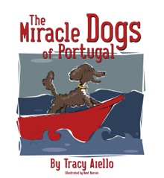
The Miracle Dogs of Portugal
Author: Tracy Aiello
Illustrator: Kent Barnes

Miracle Dogs of Portugal is the ‘almost-true’ story of Henry the Navigator, the father of Portuguese and Spanish exploration. Using Milagro, the dog that saved Henry’s life, as the ambassador to learning, the historical accuracy and context of Miracle Dogs of Portugal will inspire children to seek out more information about the “Age of Exploration.”

The book follows the classic arc of narrative fiction (exposition, rising action, climax, falling action and denouement) and is written as a porquoi in the vein of Rudyard Kipling’s Just So Stories. Children can easily identify the elements of narrative fiction, conflict, with a likable protagonist written to inspire their own journeys.

Thematic Connections
- Friendship
- Bravery
- Exploration
- Geography

Before Reading the Book

Challenging words:
Butler – servant
Meanwhile – at the same time
Royal – kingly, of kings
Protector – guard

Foreign words:
Bom Dia – Portuguese for “good morning”
Amigo – Portuguese for “friend”
Obrigada - Portuguese for “thank you”
Enchantée – French for “nice to meet you”
Ajuda - Portuguese for “help”
Mar - Portuguese for “sea”

During/After Reading
The Setting: Sagres
Locate Portugal on a world map and identify the city of Sagres. You can see images of Sagres by visiting:
- Wikipedia
- Sagres.net
- SagresUncovered.com

The Characters
“Henry”
Students can research Henry the Navigator by answering the following questions:
- When did Prince Henry the Navigator live? (1394-1460)
- What is his impact on history/American history? (Prince Henry built the first school for oceanic navigation with an observatory in Sagres. His students were trained in boat design, map-making, and science. The first boats designed at Prince Henry’s school were the same design used in the boats that Columbus sailed to America.)
- When did he build his school of navigation and astronomical observatory? (approx. 1418)
Milagro
Students can research Portuguese Water Dogs by answering the following questions:
- What were Portuguese Water Dogs bred/trained to do? (The Portuguese Water Dog breed once existed all along Portugal's coast, where it was taught to herd fish into the nets, to retrieve lost tackle or broken nets, and to act as a messenger from ship to ship, or ship to shore.)
- Why is Portuguese Water Dog important in America? (The President of the United States, Barack Obama, has a Portuguese Water Dog named Bo.)

Questions to think about after reading:
- Why did Henry love the sea? Why was Sagres a great place to dream of exploration?
- Milagro jumped in the water to save Henry when he went overboard. Why did she do that?
- The fisherman, Diego, was shocked when he learned Henry’s parents were the King and Queen of Portugal. How would you react if you realized you had just been in the company of a real prince or princess?
- If you had to give a quick summary of the main idea of the book, what would it be?

Activities
- Research Henry the Navigator and two other famous explorers. Charge students with the task to create a chart comparing the three explorers. The chart should include:
  - Years their exploration took place
  - Country of origin
  - What was the impact of their discovery?
- Research Portuguese Water Dogs. Using the resource link provided below, have students work in groups and make a poster contrasting and comparing the Portuguese Water Dog to other working breeds. Students should make a list of working dogs, their jobs, and characteristics of the dog that assist with their “jobs.” Also have them note if any of the dogs are still used today as they were long ago.
- Critical thinking. Henry the Navigator lived long ago when the world was still mostly a mystery and exploration was for the purpose of finding new lands and new resources. In today’s world, what is left to explore? Land? Technology?
  - Students can answer in a two paragraph explanation; or
  - Have students work in groups to brainstorm a place or a thing that has yet to be discovered and pretend they are explorers. Have them name their group and create a plan on how their team will lead this adventure. Where will your funding come from? Who will you ask to assist you? What will your discovery do to better the world?
  - Each group will work together to create a poster board containing all this information and any illustrations they may want to add. Have each group present their discovery to the class.

Background/References:

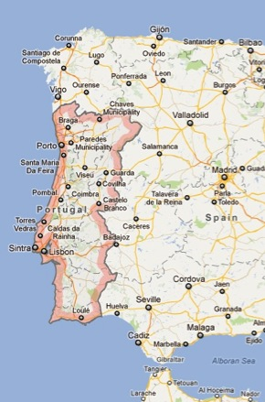
Portugal
Portugal is located in southwestern Europe on the Iberian Peninsula, which it shares with Spain. It is the westernmost country of Europe, and is bordered by the Atlantic Ocean to the West and South and by Spain to the North and East. The first County of Portugal was founded in 868, and became a democracy in 1974.
The people of Portugal speak Portuguese.

Henry the Navigator
Prince Henry, or Henry the Navigator, was born in 1394, son of King Joao of Portugal. Throughout his life, Henry’s aim was to explore, and his voyages led to the exploration of the exotic lands of Africa and opened up the southerly route to the Indies. Although he did not know it at the time, he opened the door for the exploration of the New World.

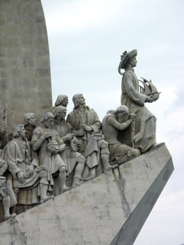
To achieve his dream of exploration, Henry knew he needed help. So he established a navigation school at Sagres, Portugal’s Land’s End. At the school, students learned navigation and new, more precise maps were created, and a new type of ship was developed, the caravel, created to be the ideal ship for exploring. Two of the ships Columbus sailed to the new world -- the Nina and Pinta -- were "caravels."

Portuguese Water Dogs
The Portuguese Water Dog was developed in Portugal where it is called Cao de Aqua (Kownd’ ahgwa) or “dog of the water”.
Bred many centuries ago, the Portuguese fishermen kept these dogs as a working part of their crew and paid them wages just like their human crewmates. The dogs helped the captains by retrieving broken nets, herding schools of fish, and carrying messages between boats and to shore. Often they would have to dive under water to retrieve items gone overboard. They sailed in boats called “trawlers’ from Portugal to as far as Iceland to bring in their catch.
The fisherman relied on the loyal dogs, yet they almost became extinct with the advent of modern shipping and the invention of the radio. A small number of U.S. breeders brought them back in the 1970s. Now there are more than 4500 Portuguese Water Dogs living in the United States and Canada. The breed is believed to be the father of the modern Poodle, Irish Water Spaniel, Kerry Blue Terrier, Labrador Retriever, Curly Coated Retriever, and Newfoundland.

Websites:
Portugal:
http://en.wikipedia.org/wiki/Portugal

Prince Henry the Navigator: http://www.enchantedlearning.com/explorers/page/h/henry.shtml
http://catterall.net/cotrim/soares/Sagres.html

Portuguese Water Dogs:
http://www.akc.org/breeds/portuguese_water_dog/history.cfm

Discovery & Exploration:
http://memory.loc.gov/ammem/gmdhtml/gmdhome.html
http://www.marinersmuseum.org/education/columbus-first-voyage-map

